Angular final task

Here is the assignment to build angular project  
Create a compresive SPA

angular application using the following concepts

* Components

* Parent Child Components

* Directives(Structural,Attribute)

* @Input,@Output

* Routing and Routing Parameters

* Local Storage

* Routing Gaurd

* Services and observables

* API Call

* Form Handling ( Template and Model Based Approach)

* Inbuilt Pipes

* Custom Pipes

For this assignment I created a author portfolio using all the concepts in the angular as listed in above  
let me provide you the output screenshot of it

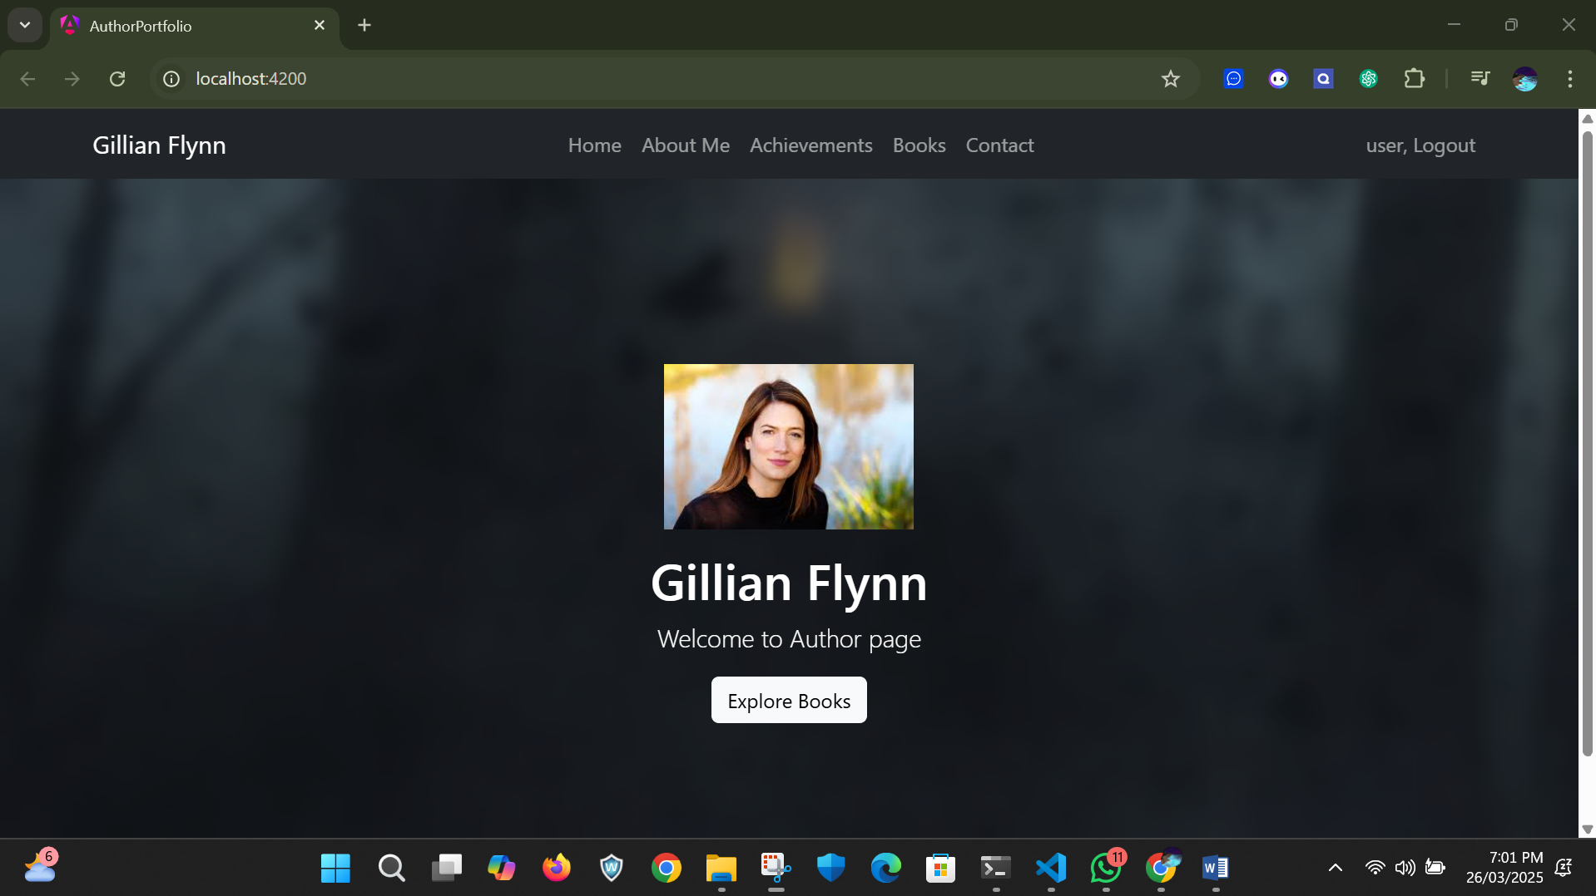

Here is the homepage of my author portfolio and when we click the explore books button it will navigate to books section.

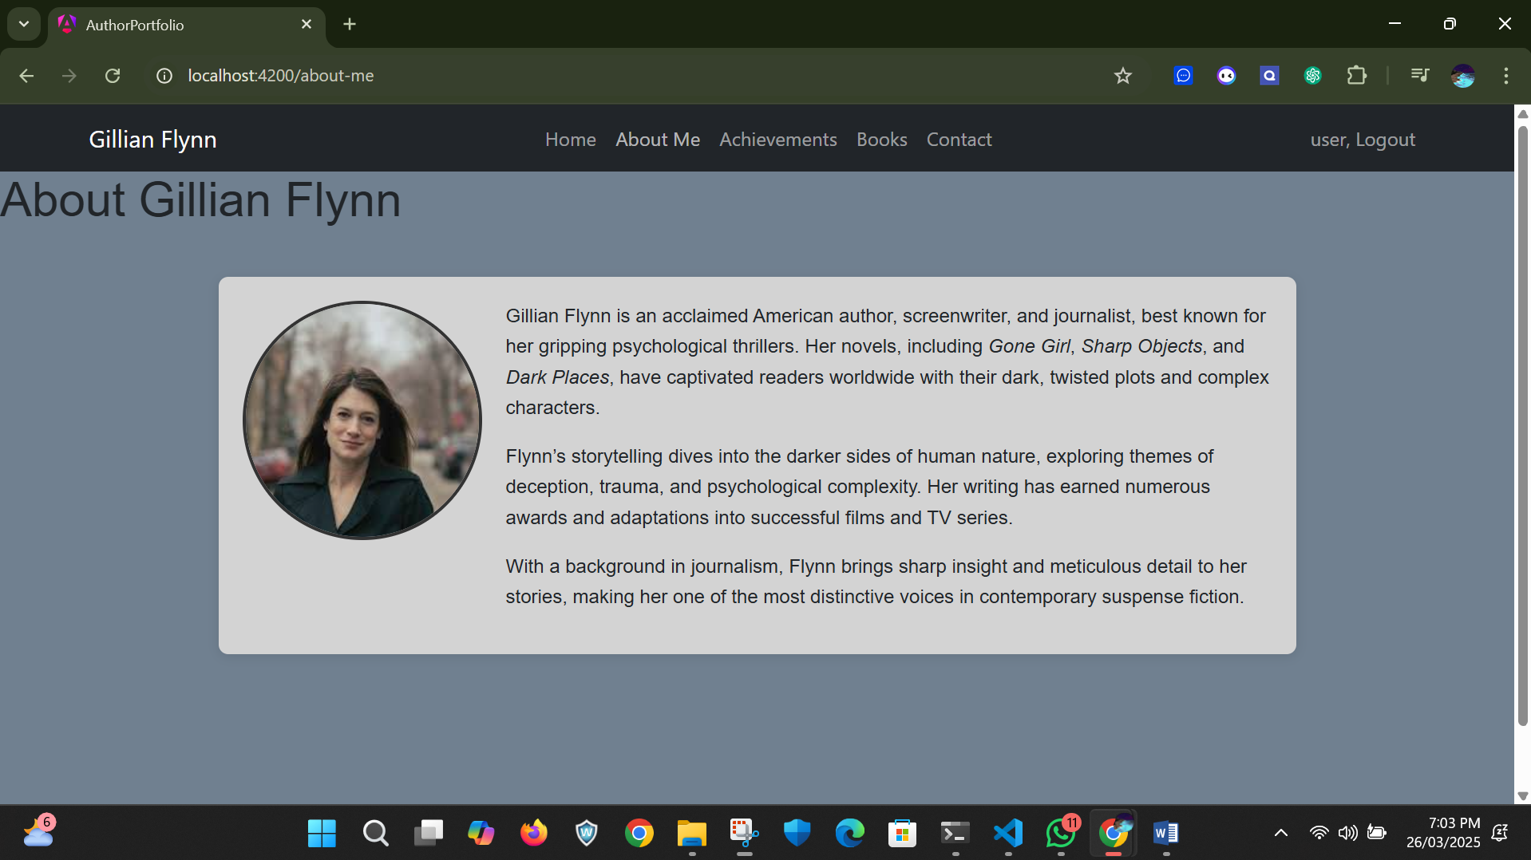

Here is the author about-me section

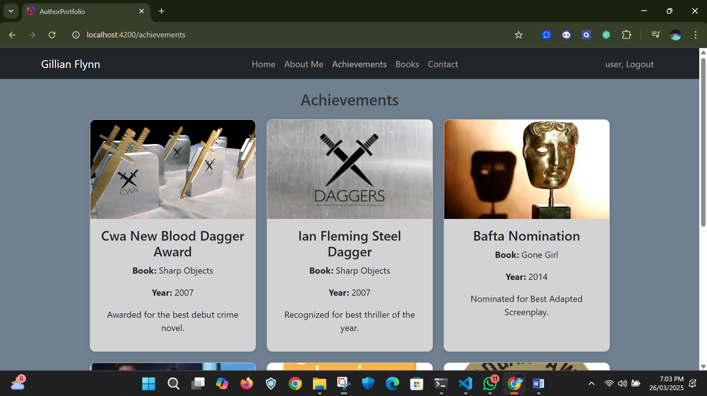



Here is the achievement section of the author where it shows the author’s achievement details were provided in the card.

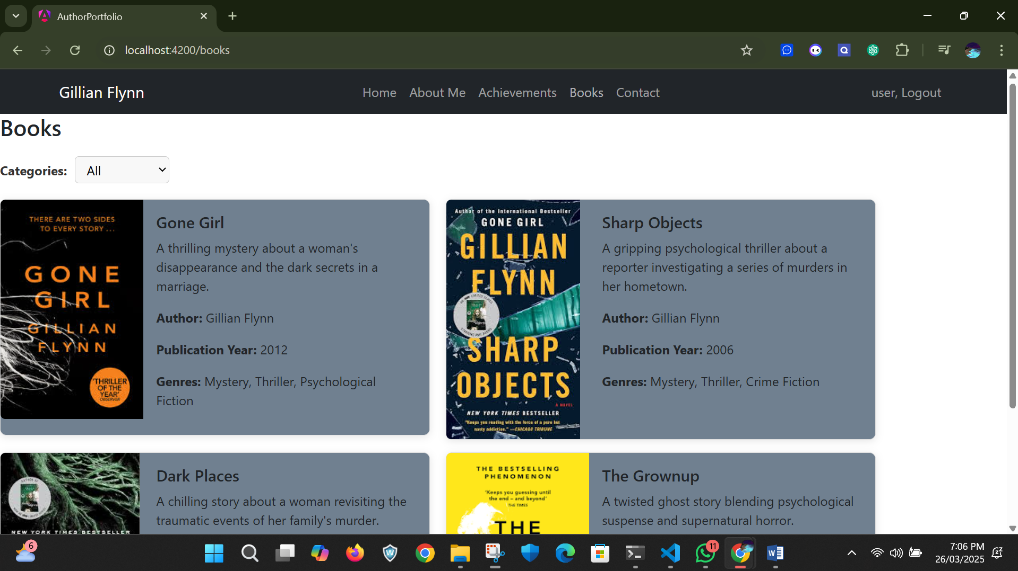

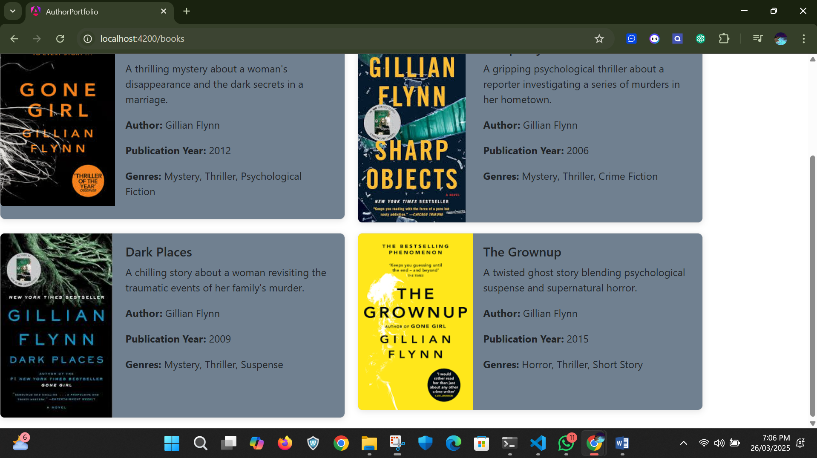

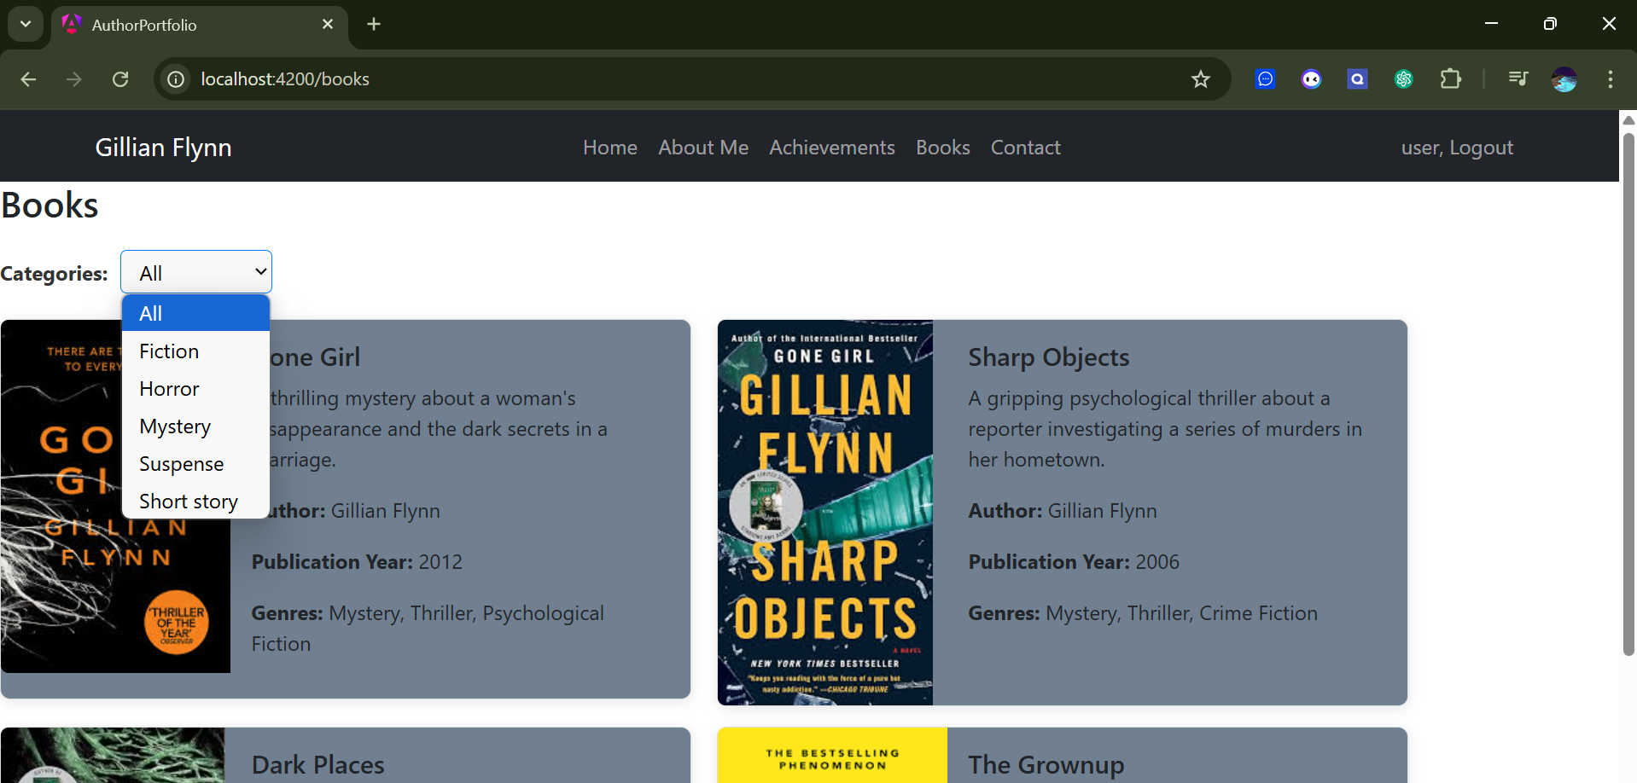

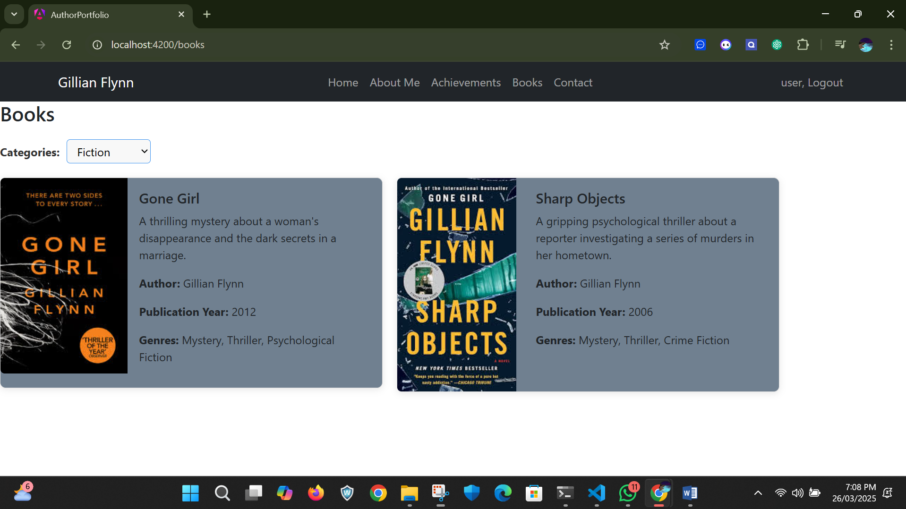



Here is the books section where we all the author’s book were displayed here and we can also filter the books according the genres for that I used custom pipes here.

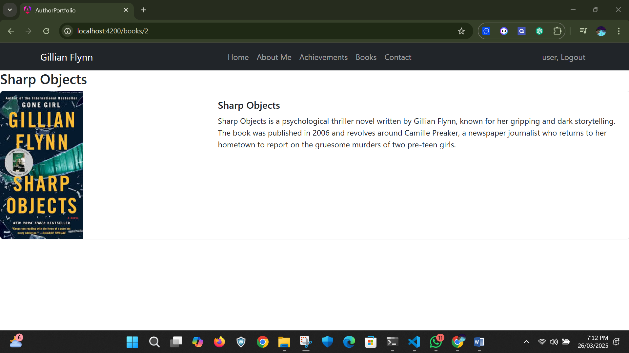

When I click into a particular book card it navigate to that particular book detail section.

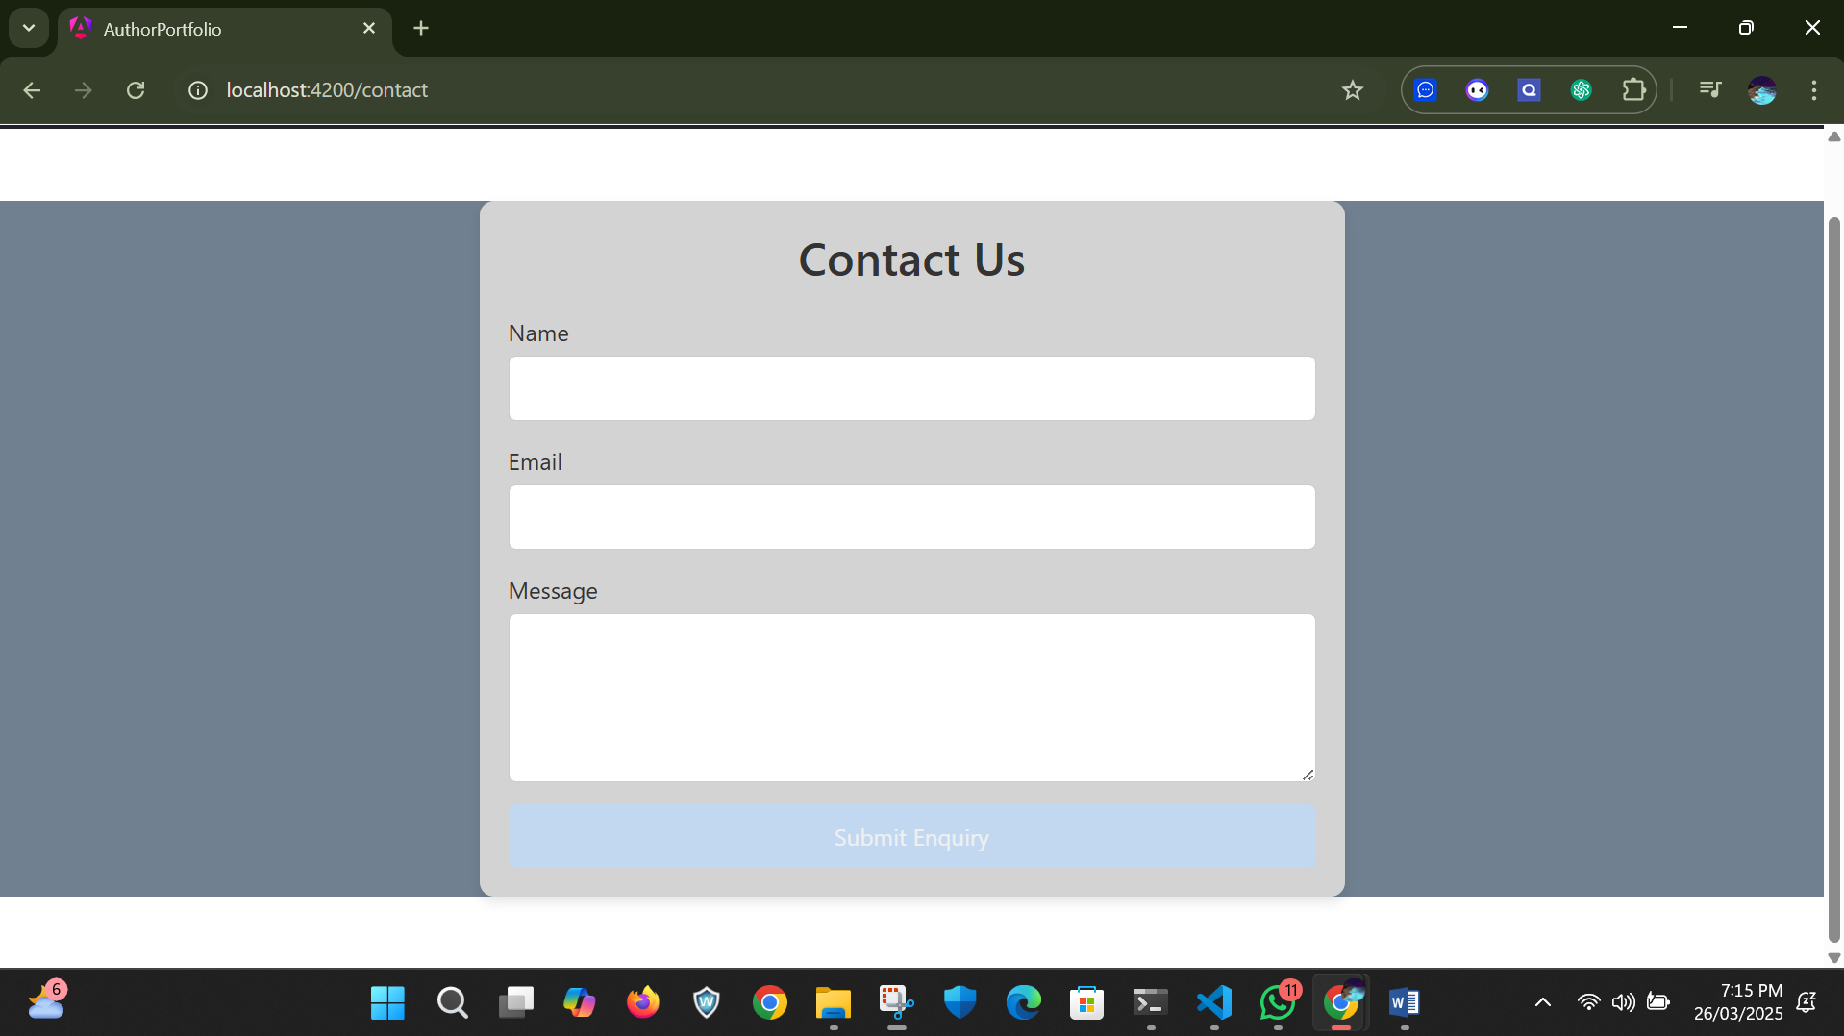

Here is the contact us section in author portfolio were the reader or anyone can send message to author.  
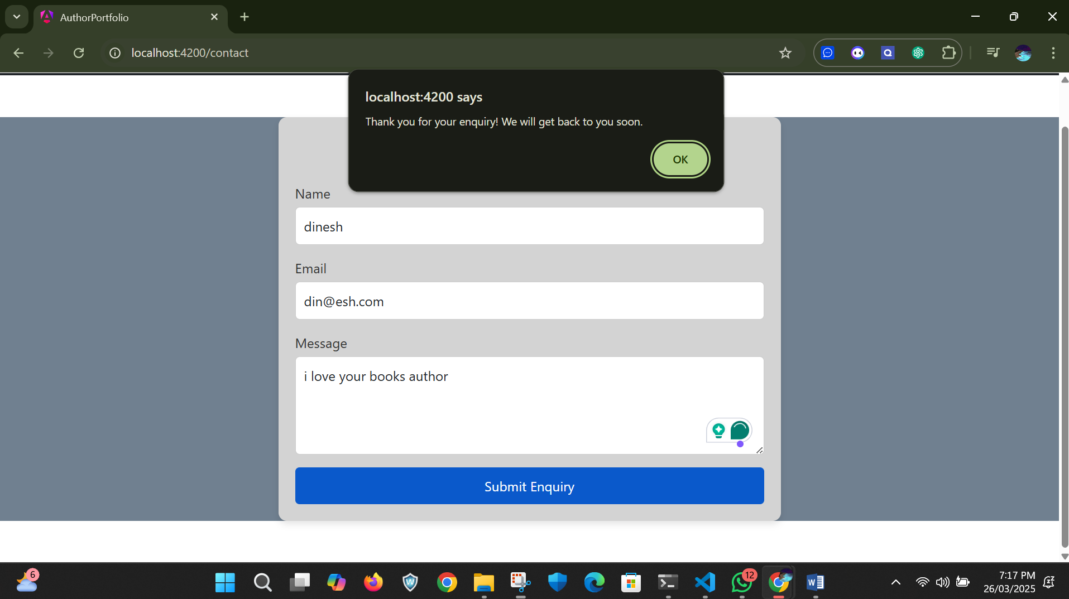

When we submit the equiry a dialog box will pop-up to notify the submission of the query is successful.

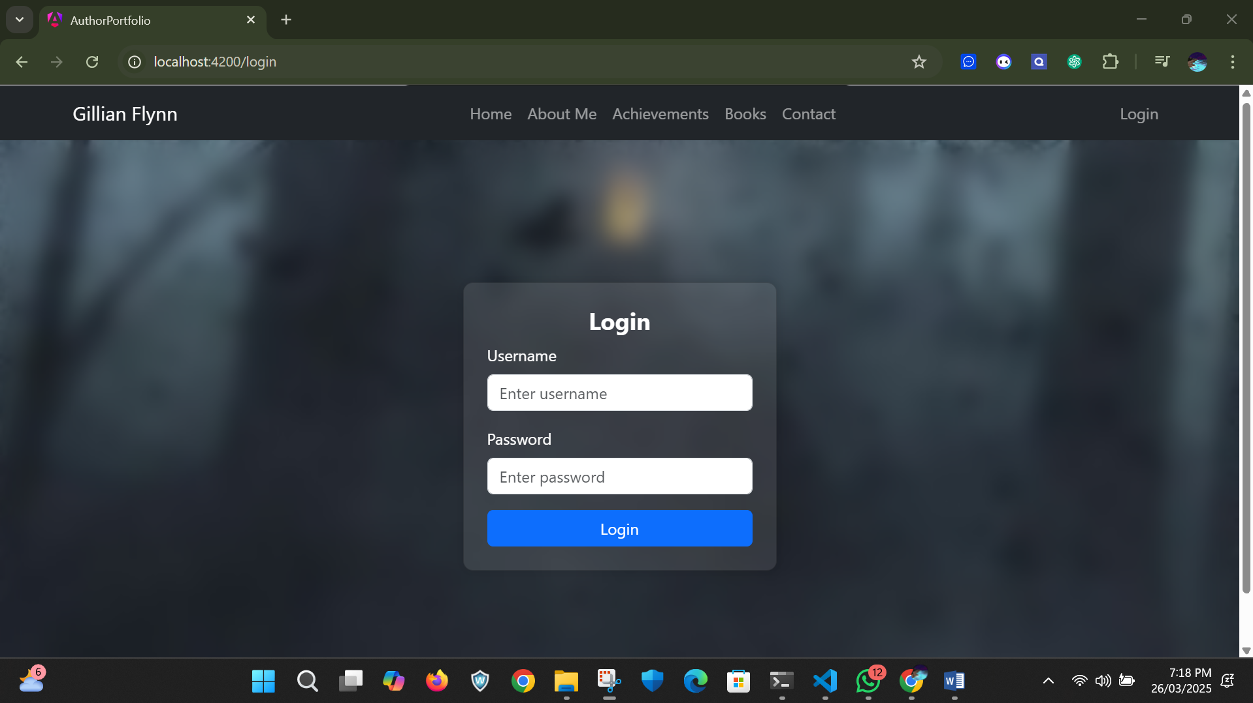

Here is the login page here I provide two login credential one as admin and other one is user if I give anyother credential than this it shows invalid credential

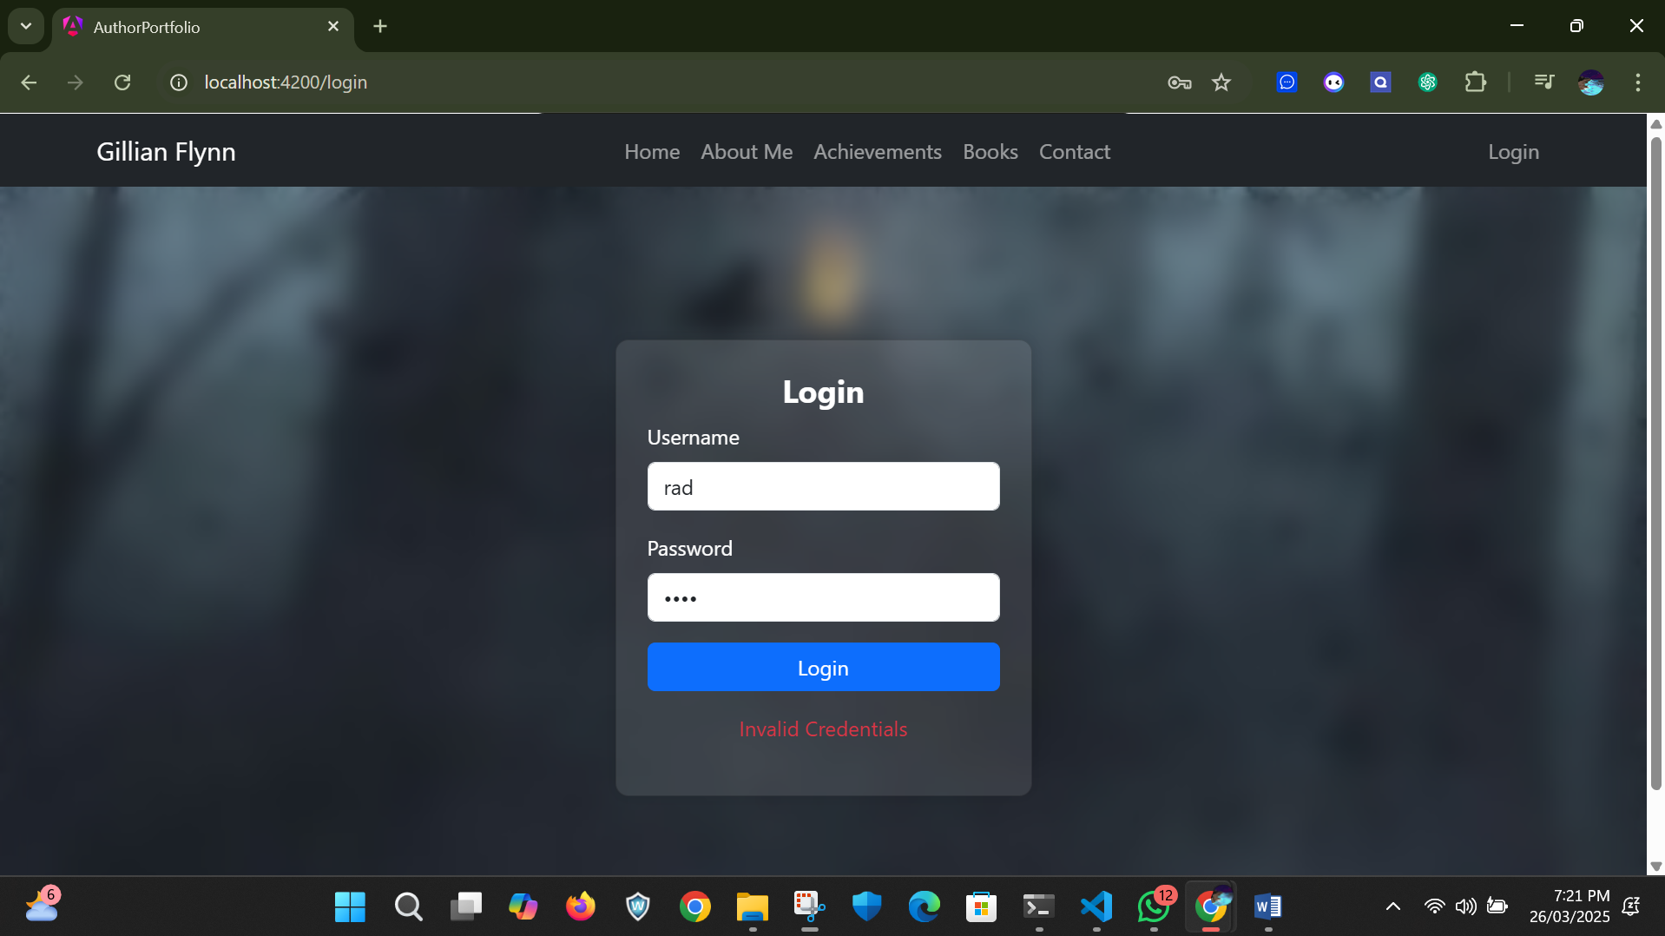

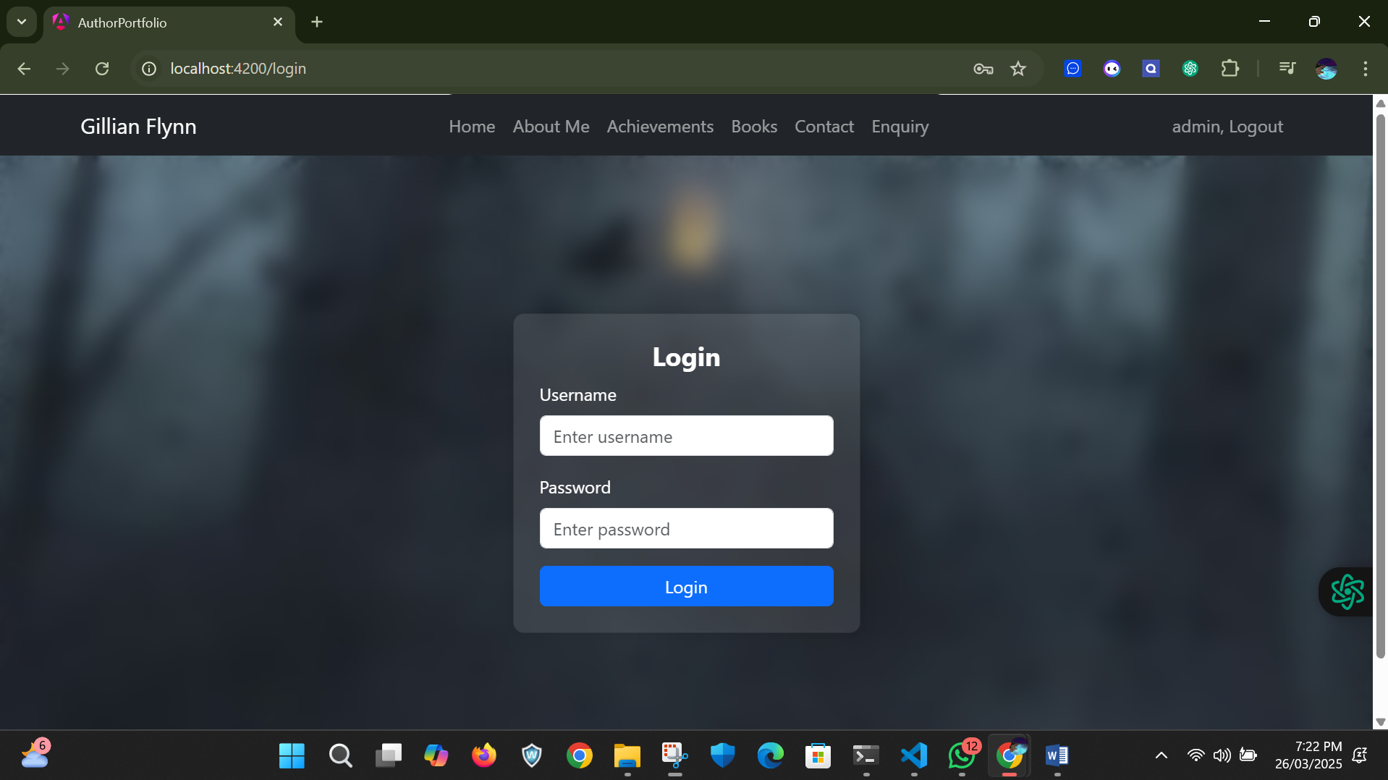

When I login into admin we can see a additional section is added which is named as enquiry which is the query submitted by user as it only visible to admin for that we used routing guards.

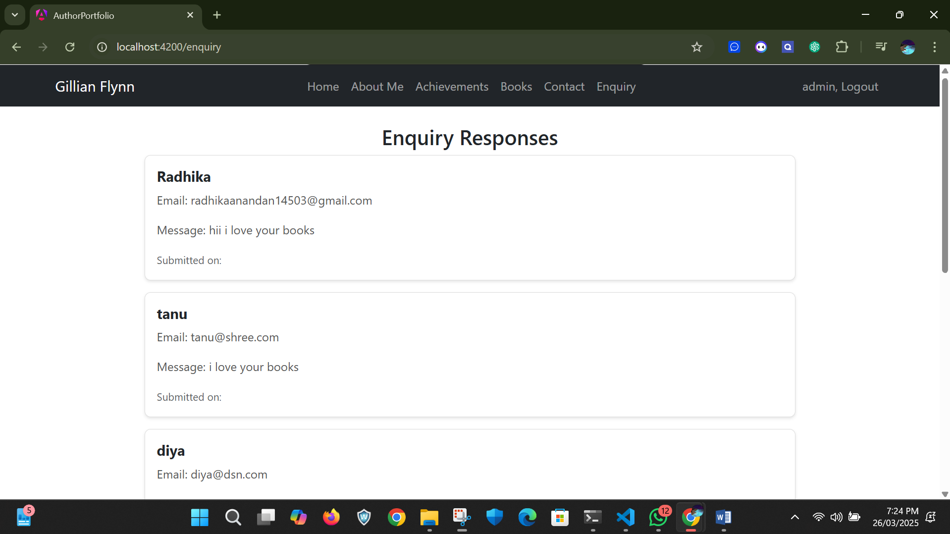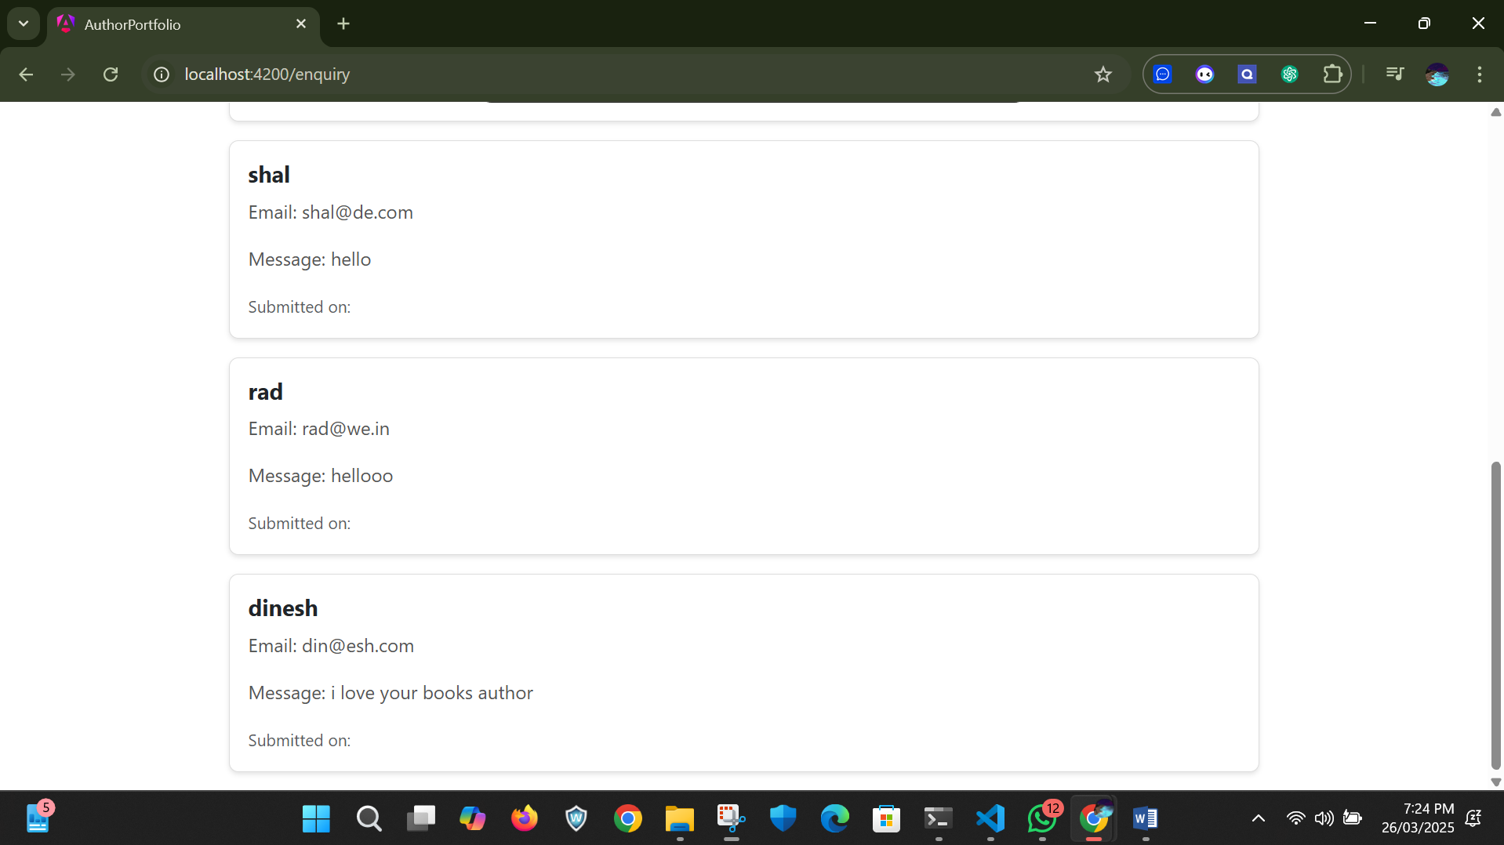

Let me login by using user credential now  
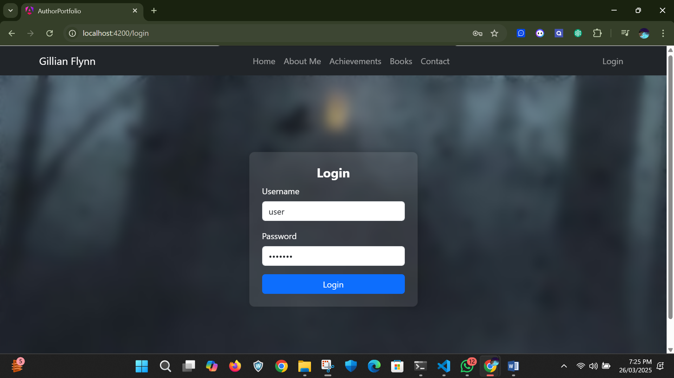

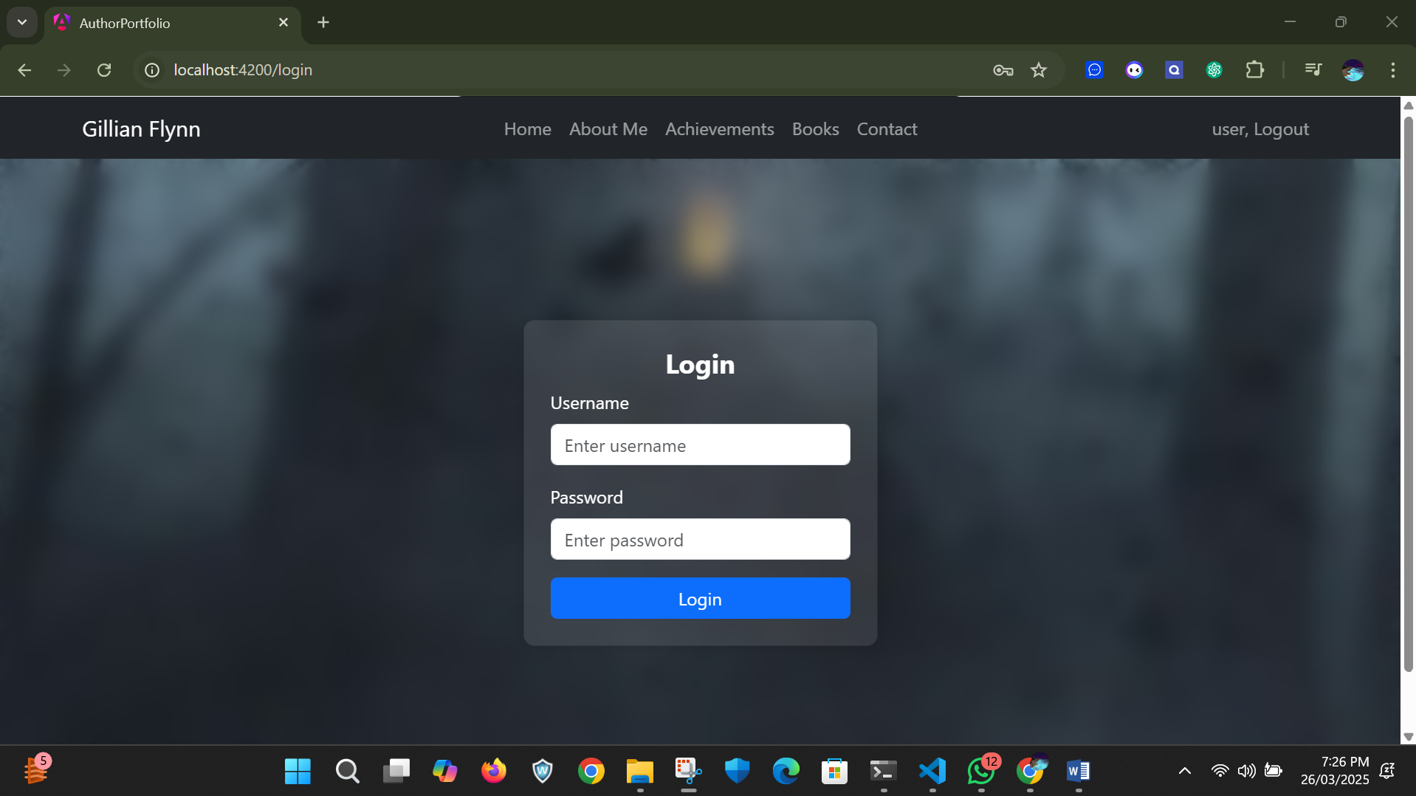

Here when I logged into user credential the enquiry section is not available.

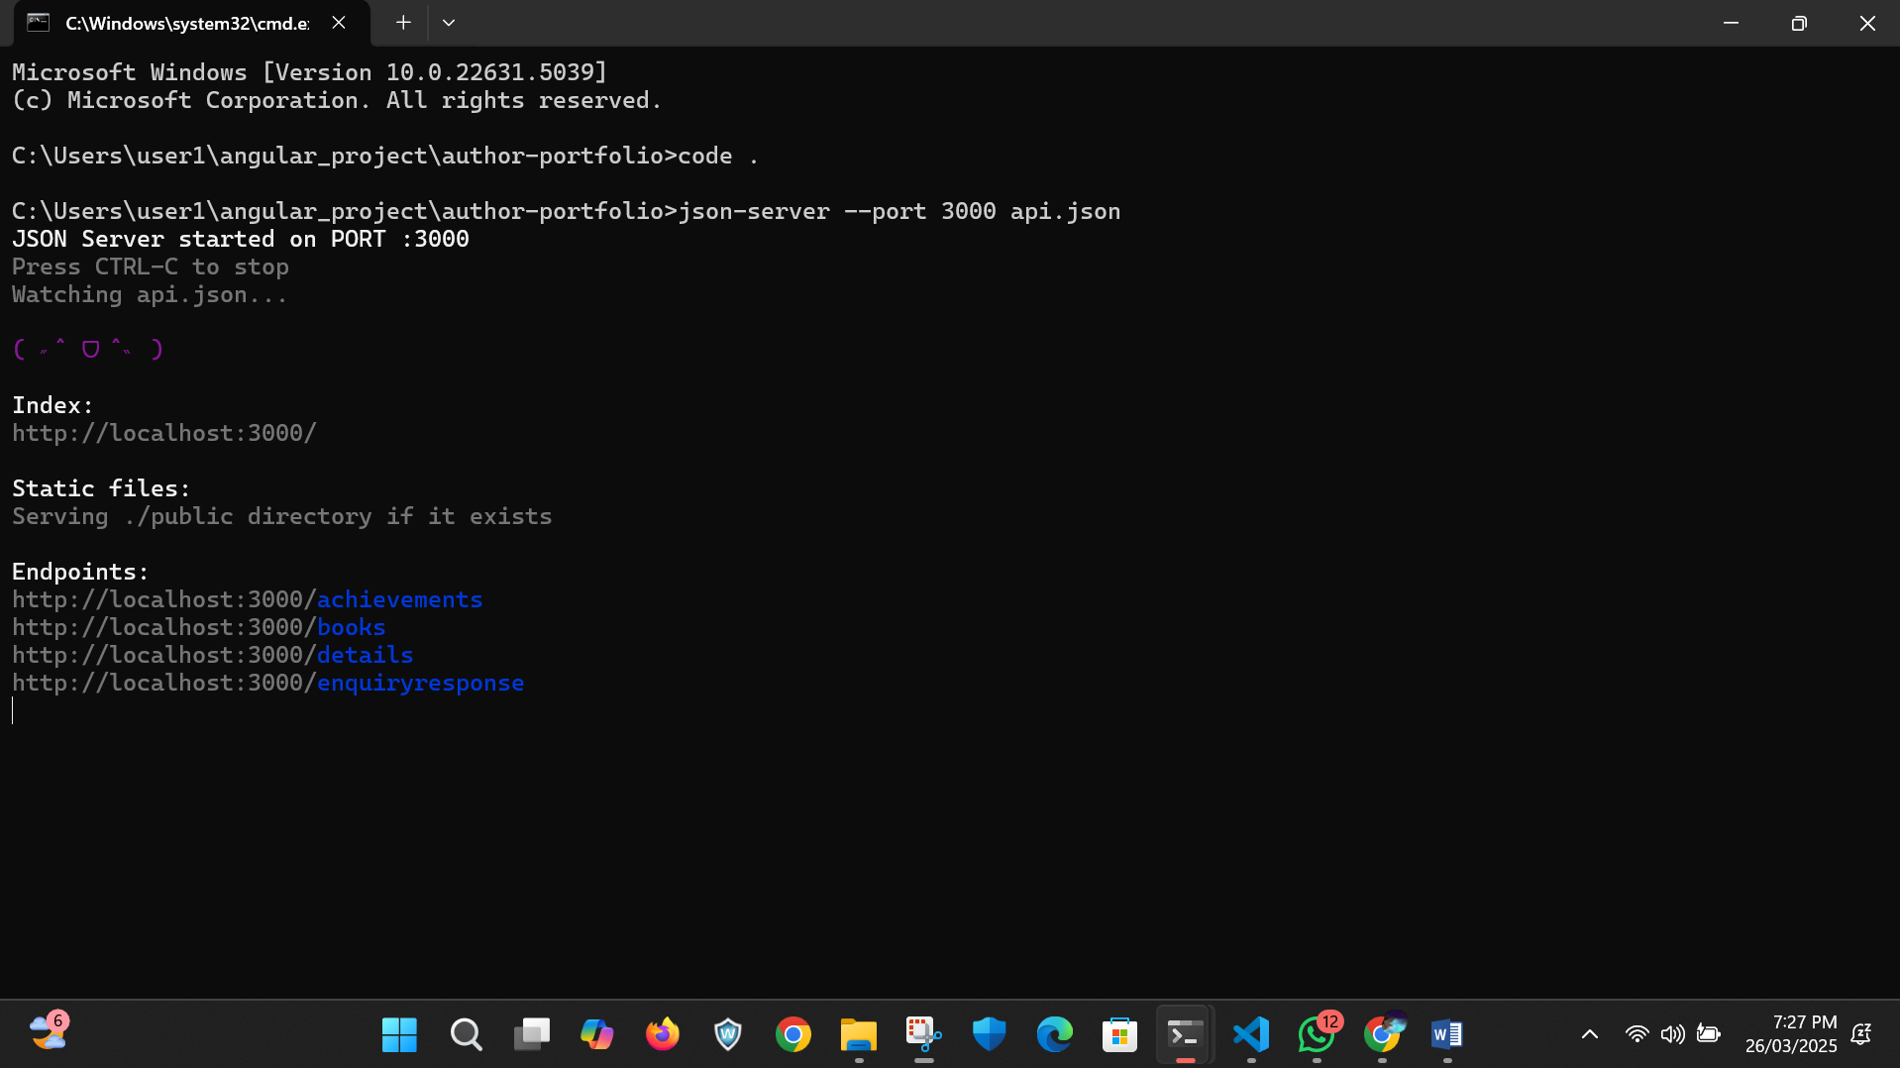

For the data for achievements, books etc I used json api server where the data were stored. 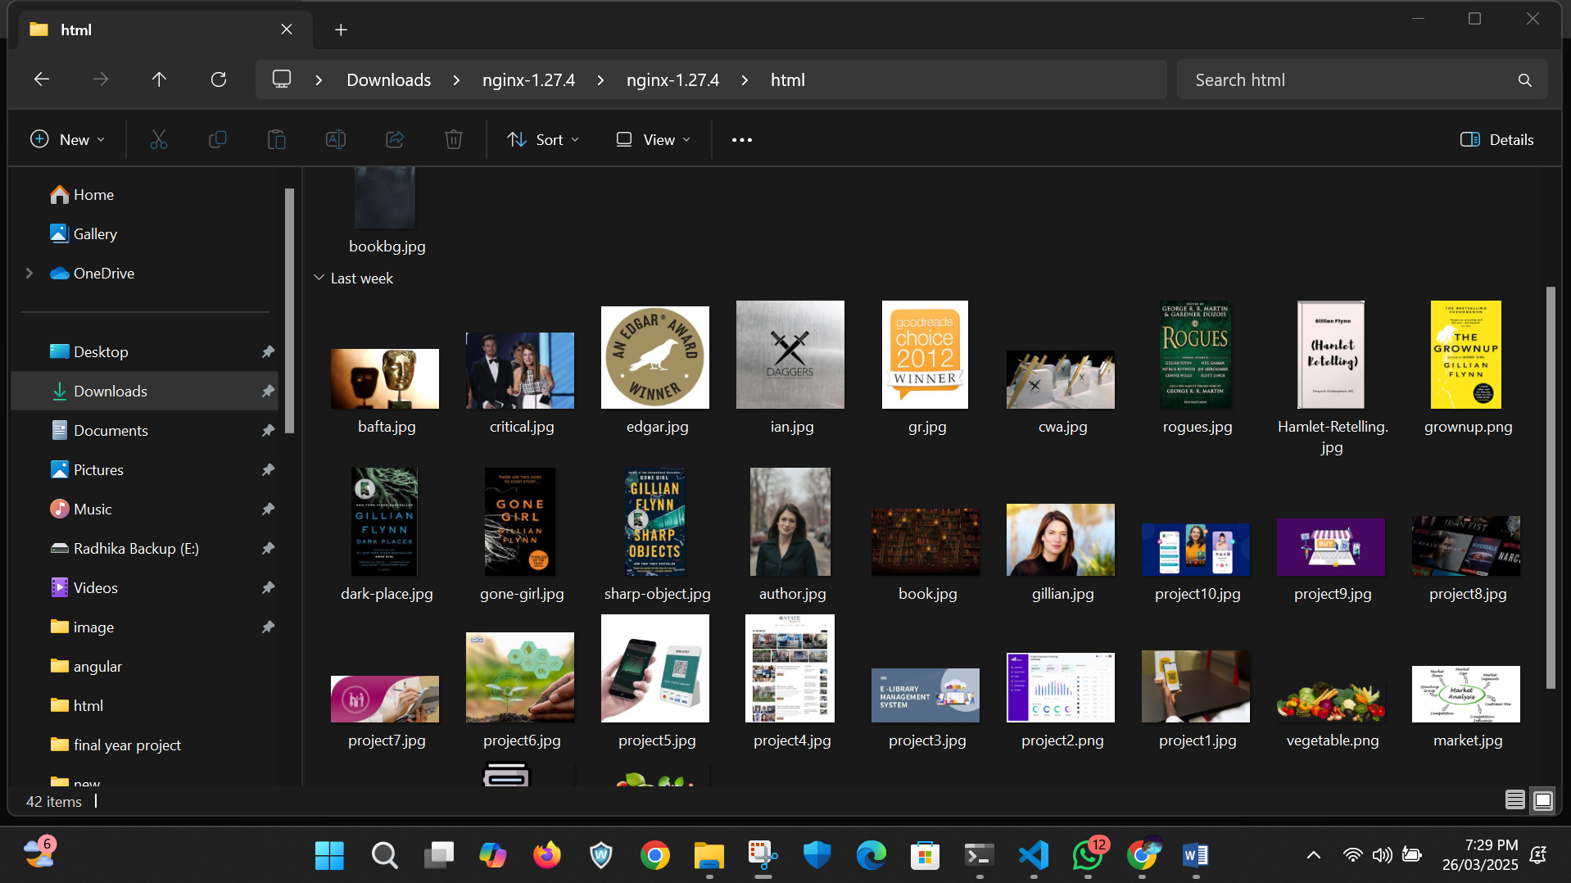

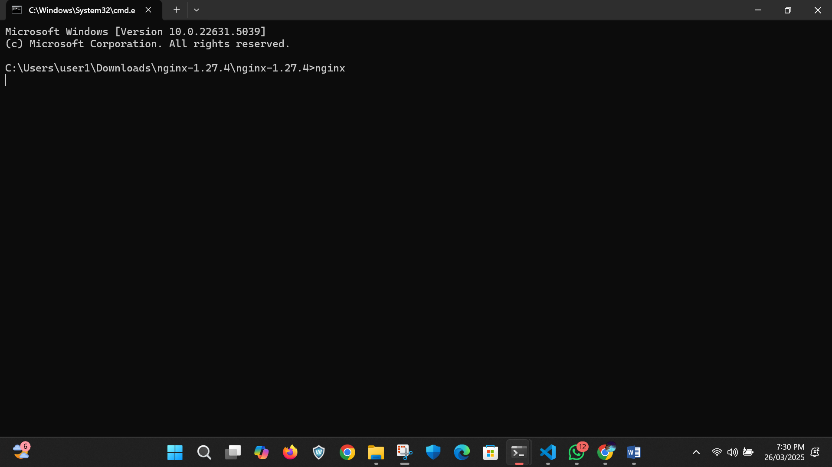

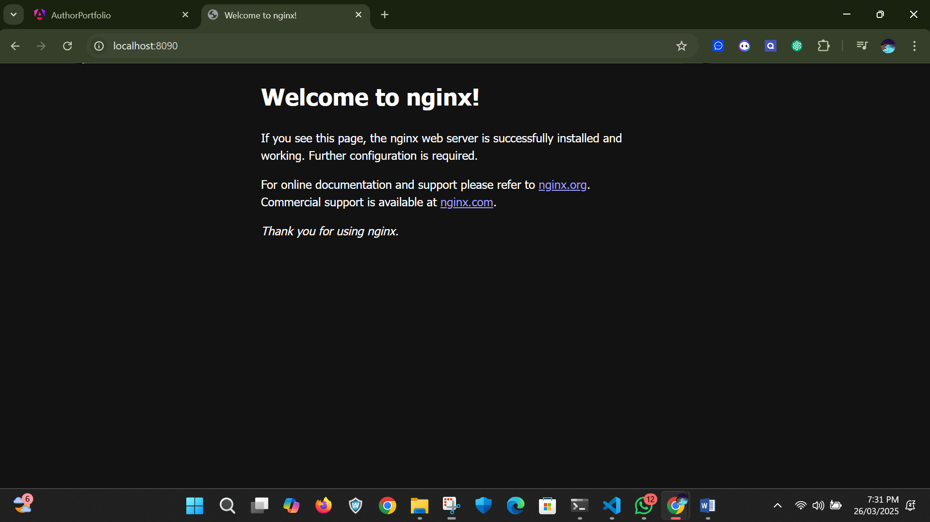

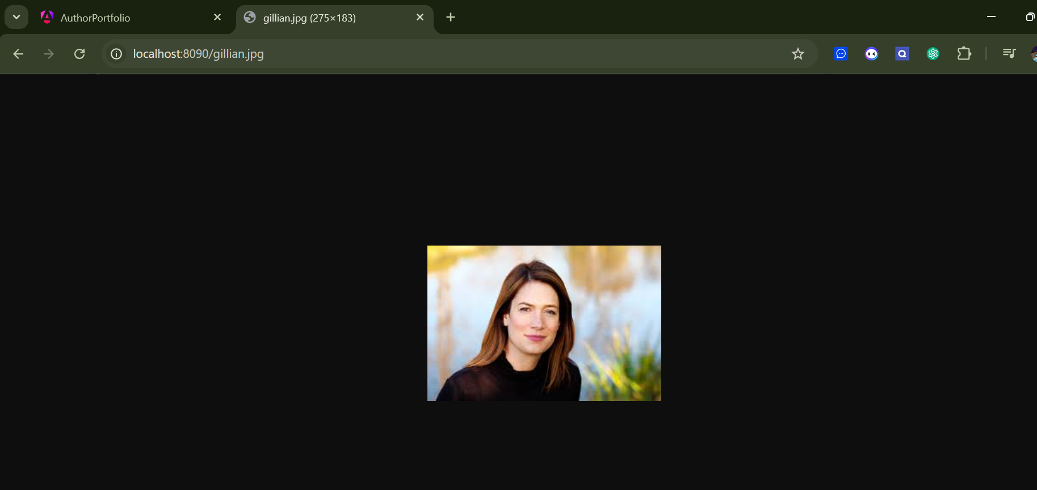

For images I stored it in the nginx when I started it in command we can see the images that we stored in nginx html folder in localhost.

Conclusion:

As we see here a single responsive angular project was created successfully.